# Experiment No: 13

**Aim**

Build sample collections/documents to perform the shell queries

# CO5

Apply CRUD operations and retrieve data in a NoSQL environment.

# Procedure

1. Create/Use a database

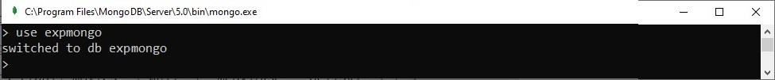> use expmongo

1. Display current database

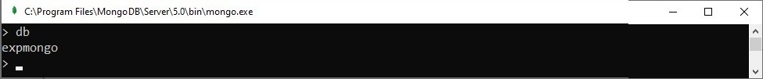>db

1. Create a collection

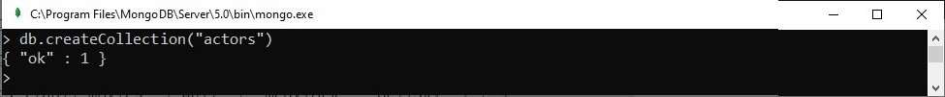>db.createCollection("actors")

1. 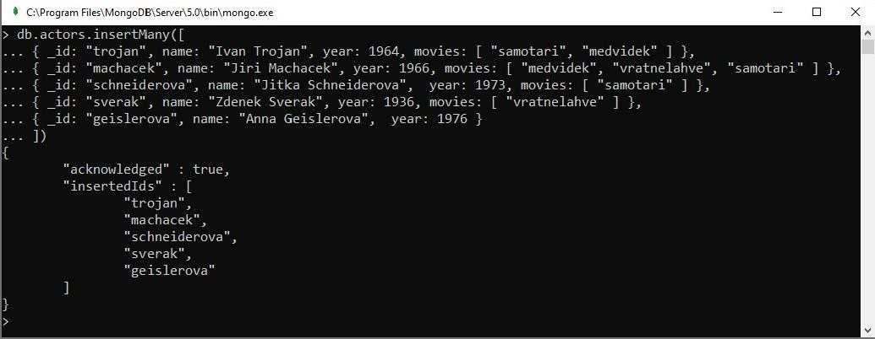Insert data into the collection
2. Display documents in collection

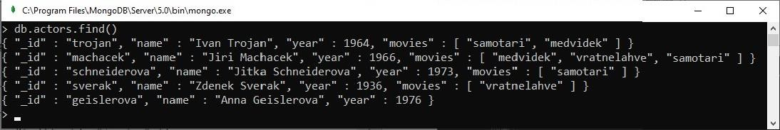>db.actors.find()

1. Display documents in collection

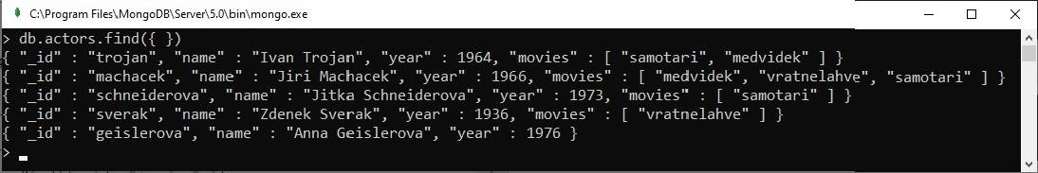>db.actors.find({ })

1. Display

>db.actors.find({ _id: "trojan" })

1. Display

>db.actors.find({ name: "Ivan Trojan", year: 1964 })

1. Display

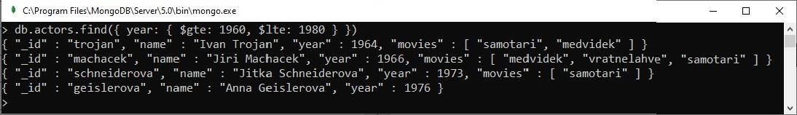>db.actors.find({ year: { $gte: 1960, $lte: 1980 } })

1. Display

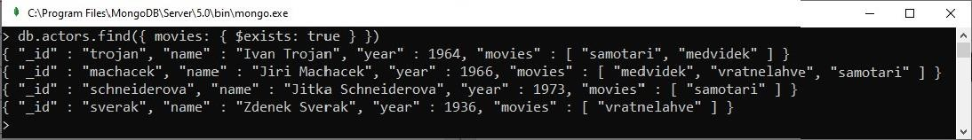>db.actors.find({ movies: { $exists: true } })

1. Display

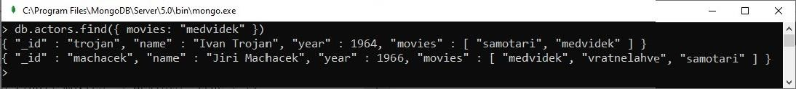>db.actors.find({ movies: "medvidek" })

1. Display

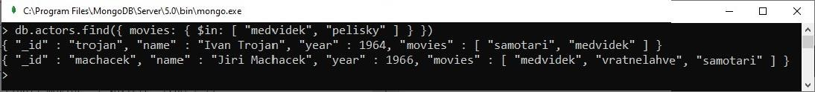>db.actors.find({ movies: { $in: [ "medvidek", "pelisky" ] } })

1. Display

>db.actors.find({ movies: { $all: [ "medvidek", "pelisky" ] } })

1. Display

>db.actors.find({ $or: [ { year: 1964 }, { rating: { $gte: 3 } } ] })

1. Display

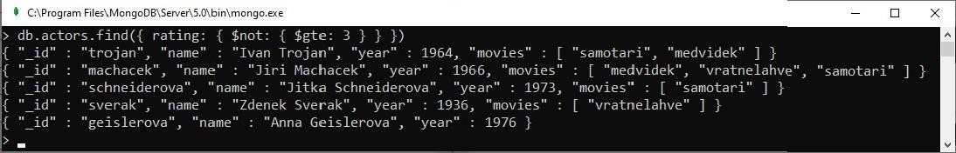>db.actors.find({ rating: { $not: { $gte: 3 } } })

1. Display

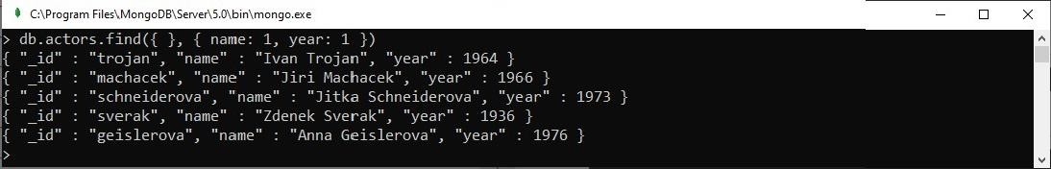>db.actors.find({ }, { name: 1, year: 1 })



1. Display

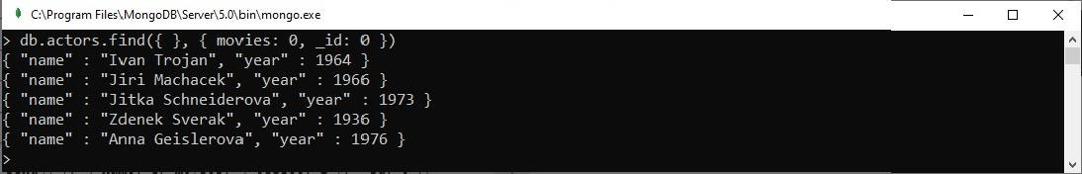>db.actors.find({ }, { movies: 0, _id: 0 })

1. Display

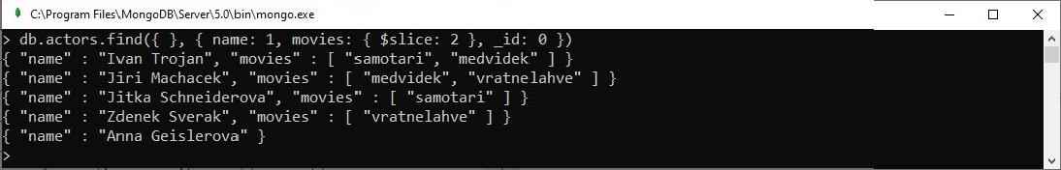>db.actors.find({ }, { name: 1, movies: { $slice: 2 }, _id: 0 })

1. Display

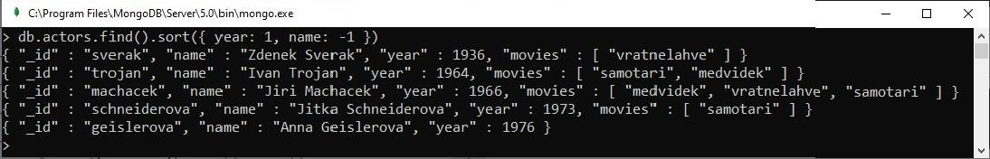>db.actors.find().sort({ year: 1, name: -1 })

1. Display

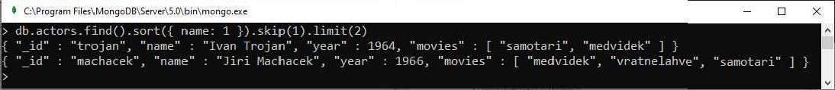>db.actors.find().sort({ name: 1 }).skip(1).limit(2)

1. Display

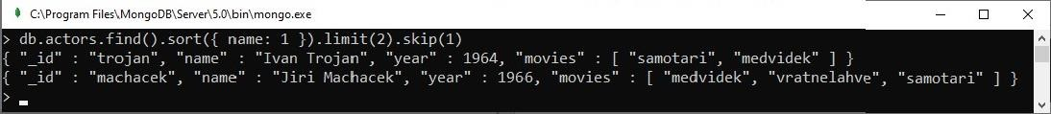>db.actors.find().sort({ name: 1 }).limit(2).skip(1)

# Result

The program was executed and the result was successfully obtained. Thus CO5 was obtained